PUSHING REPOSTROY INTO GITHUB VIA GIT BASH

Step 1:

Create a folder name it as proj1 or else in your desktop.

Step 2:

Now open git bash terminal

Now add the desktop directory using command   
 cd proj1   
  


Step 3:

Now we have to initialize the project . to initialize use command as git init  
  
  
Step 4:

To create the file In this folder we use the command touch text.txt



Step 5:

Use the command to check wheather the file is inserted in the folder or not git status  
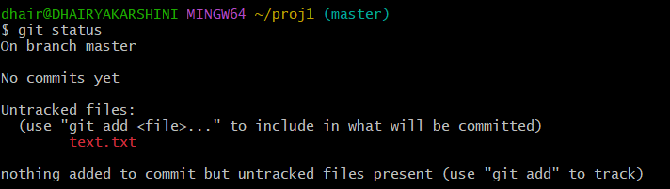  
  
 To check the list of the files in this folder we use   
this command ls  


Step 6:

To add file into folder use git add . 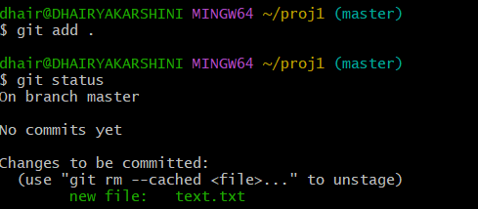

Step 7:

Now create a repository in a git hub as shown

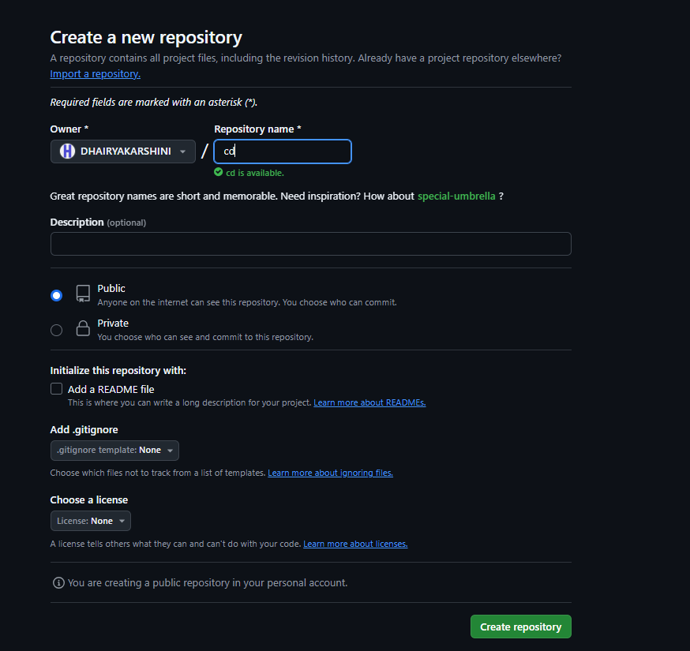  
click on create repository

Go to bash and commit the changes using this command git commit -m "first commit”  
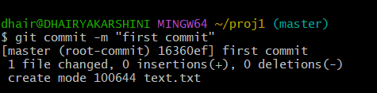



Step8:

Now goto github

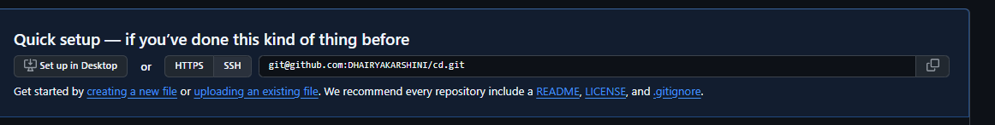

Copy this link $ git remote add origin @your email

Add this command to push the repository into the git

git push --set-upstream origin master

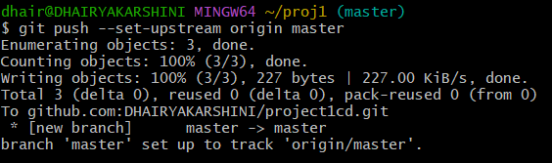



You have sucessfully pushed the repository into git hub.